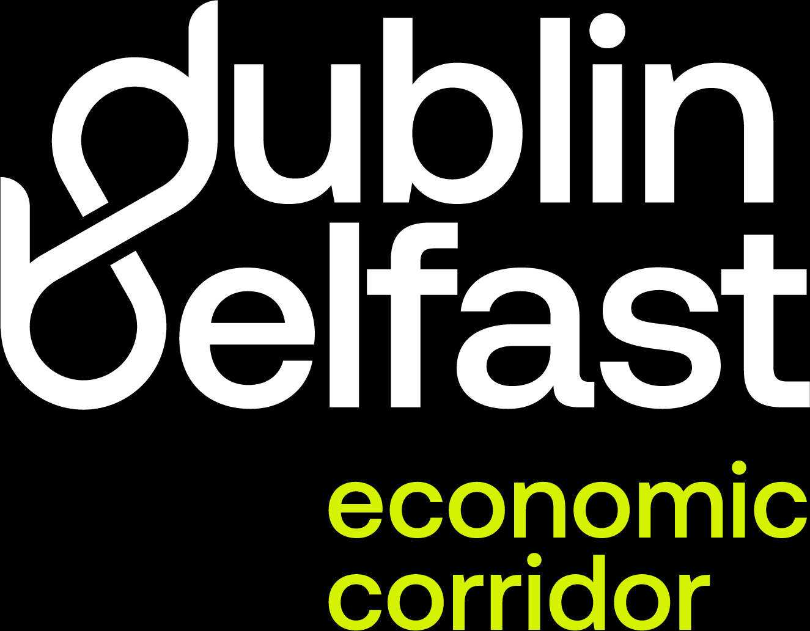


What is the Dublin Belfast Economic Corridor?
The Dublin Belfast Economic Corridor (DBEC) is a leading economic area on the island of Ireland. Stretching 100 miles between Dublin and Belfast, the Corridor is home to one-third of the island’s population and one-third of its business base, supported by a highly skilled talent pool.
DBEC is a prime investment destination, with strengths across technology, advanced manufacturing, financial and professional services, life sciences and agri-food industries. The Corridor offers seamless connections to national and international markets while fostering enterprise, talent, and innovation.
With high-quality transport links, excellent education opportunities, and access to a wide range of amenities, the Dublin Belfast Economic Corridor provides an outstanding quality of life for those who live and work across the region.

