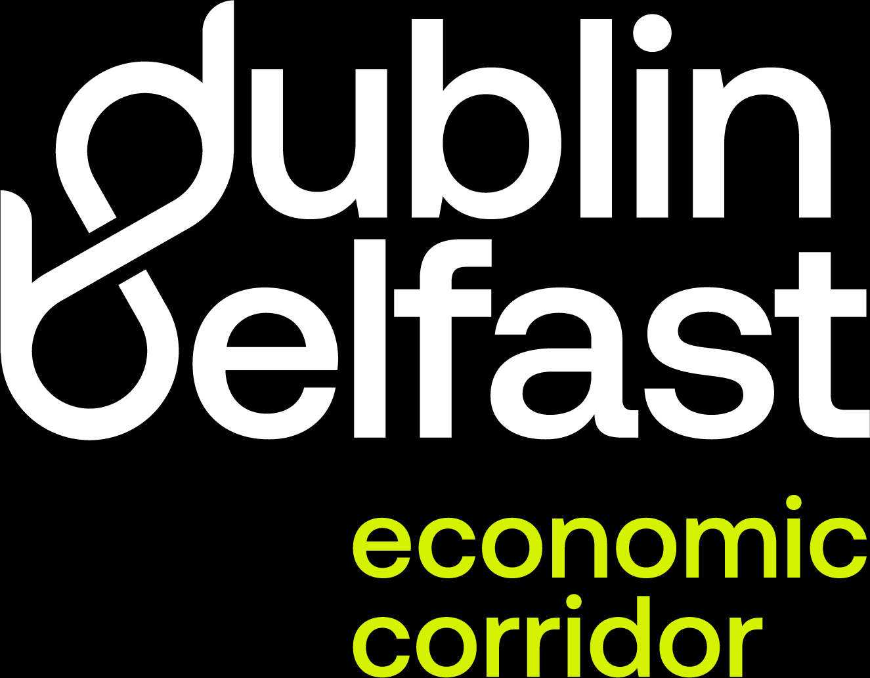


Key messages about the Dublin Belfast Economic Region
• The Dublin Belfast Economic Corridor is a leading economic region on the island of Ireland. Covering the 100 miles between Dublin and Belfast, the corridor is home to one-third of the island’s population, boasts a highly skilled talent pool, collaborative R&D opportunities and one third of the business base, all delivering sustainable growth for the region.

• The Dublin Belfast Economic Corridor is an investment destination for several sectors including Fintech, Advanced Manufacturing, Life Sciences, and Agri Food, amongst others. Thanks to its unique location the corridor connects national and international markets, and it supports enterprise, talent and innovation. By positioning themselves within the corridor, companies of all sizes and stages can access cross-border business support to help their businesses grow.

• The corridor enjoys well-connected transport links, education opportunities and access to quality healthcare, housing and amenities, and provides those living and working in the region with an excellent quality of life.

