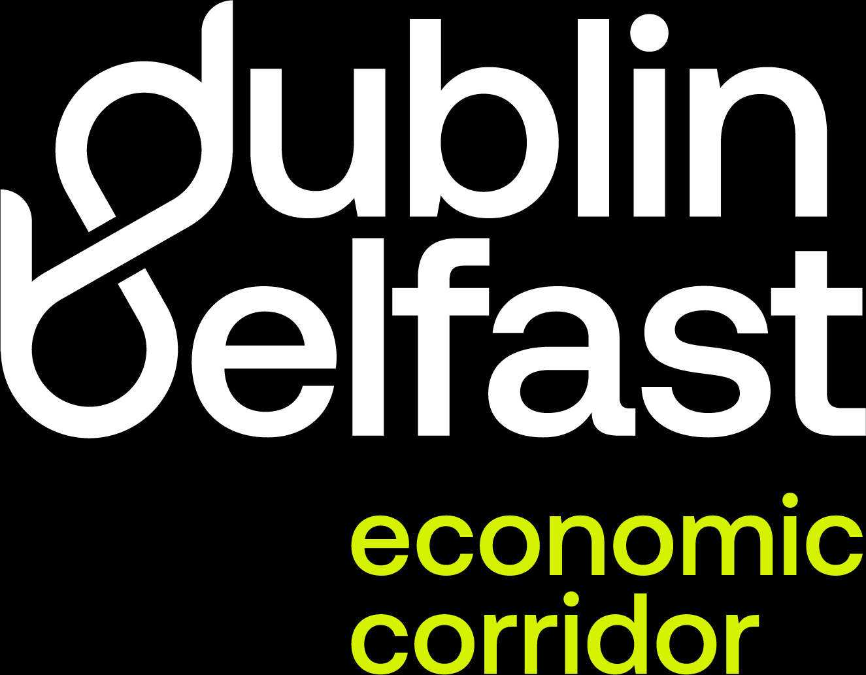


Key facts about the Dublin Belfast Economic Corridor
- DBEC is home to one-third of the island’s population with a young, skilled workforce; key growth sectors include Professional & Financial Services, ICT, Health & Social Work, and Tourism.

- 39% of the island’s active businesses, over a third of new business births, and 42% of agency-supported businesses are located in the DBEC.
- 47% of employment in exporting and innovation-active SMEs and multinationals is in the Corridor.

- Forecasts suggest DBEC could generate 53% of the island’s 600,000 new jobs by 2033 and €800m GVA growth by 2030 (€4bn cumulative).

